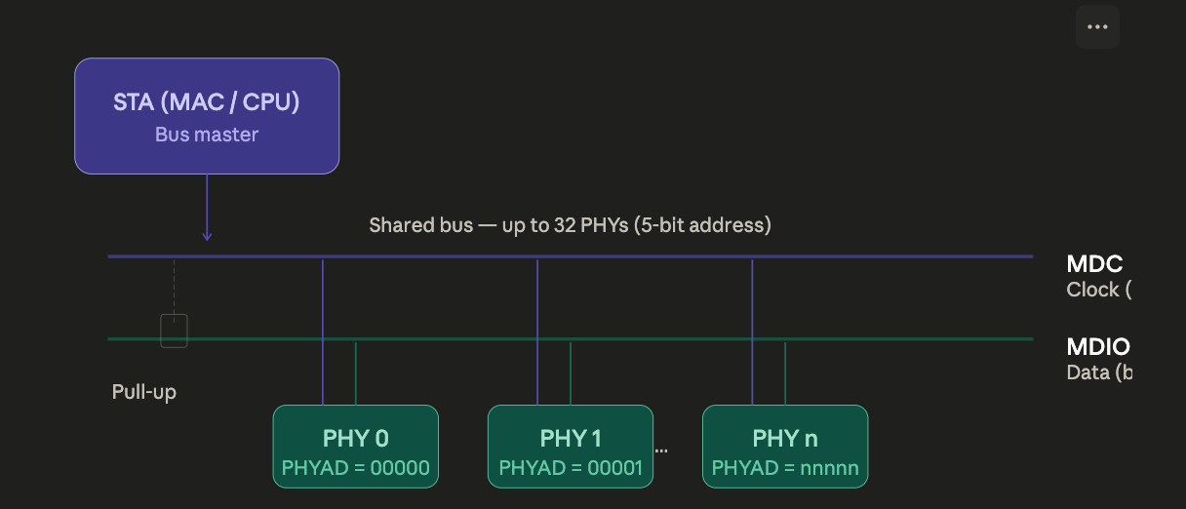
MDC/MDIO is the management sideband of every MII-family interface. While the data path (TXD/RXD) carries Ethernet frames at line rate, MDC/MDIO is a slow, serial, two-wire bus that the MAC uses to configure and monitor the PHY — reading link status, setting speed/duplex, accessing diagnostic counters, tuning equaliser taps, and so on. It is conceptually similar to I²C: one clock line, one bidirectional data line, one master (the MAC or STA), up to 32 devices on the bus.

The electrical behaviour is straightforward. MDC is a free-running clock driven by the STA (station management entity — typically the MAC or a CPU), with a maximum frequency of 2.5 MHz. MDIO is an open-drain bidirectional line with an external pull-up resistor. During a write, the STA drives MDIO on both the frame and data fields. During a read, the STA drives the frame header, then releases MDIO and the addressed PHY drives the data back — the turnaround bits handle the handoff.

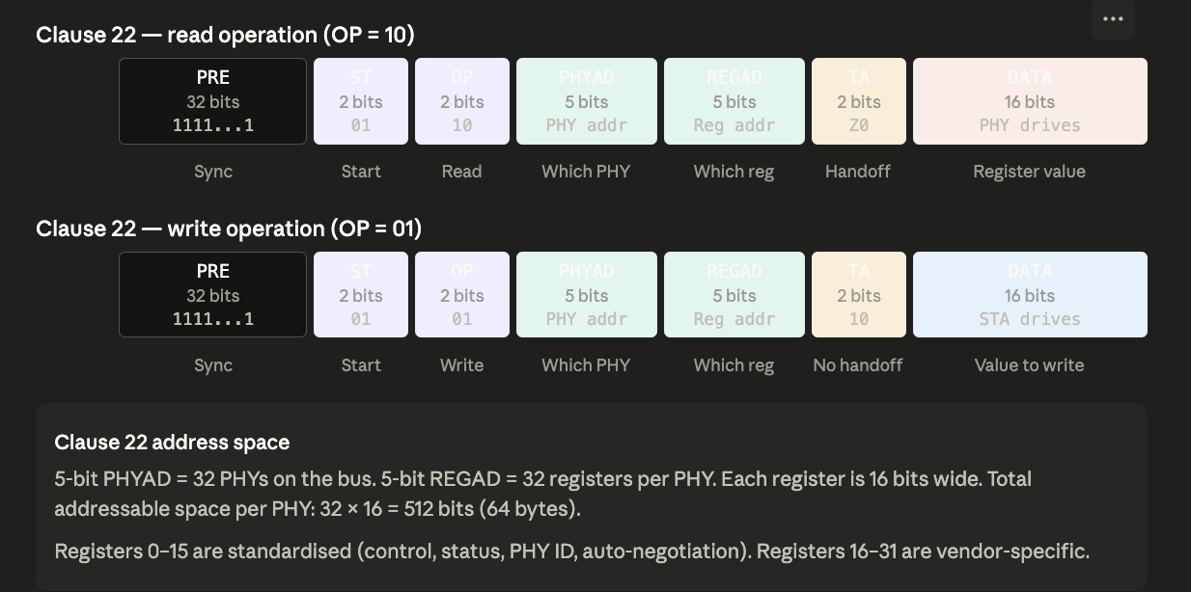

The Clause 22 frame is 64 bits total (32 preamble + 32 frame). Every field is STA-driven except during a read, when the turnaround (TA) field acts as the handoff: the STA releases MDIO (drives Z, high-impedance), then the PHY drives a 0 to acknowledge, followed by 16 bits of register data. During a write, the STA keeps driving through TA (sending 10) and straight into the 16-bit data field — no bus turnaround needed.
The critical limitation of Clause 22 is the 5-bit register address: only 32 registers per PHY. For 10/100 Mbps PHYs with a handful of configuration and status registers, 32 was sufficient. But 10 Gigabit PHYs, and even complex Gigabit PHYs with diagnostic counters, eye-diagram monitors, cable diagnostics, and timestamping engines, need thousands of registers. Clause 45 solves this with indirect addressing.
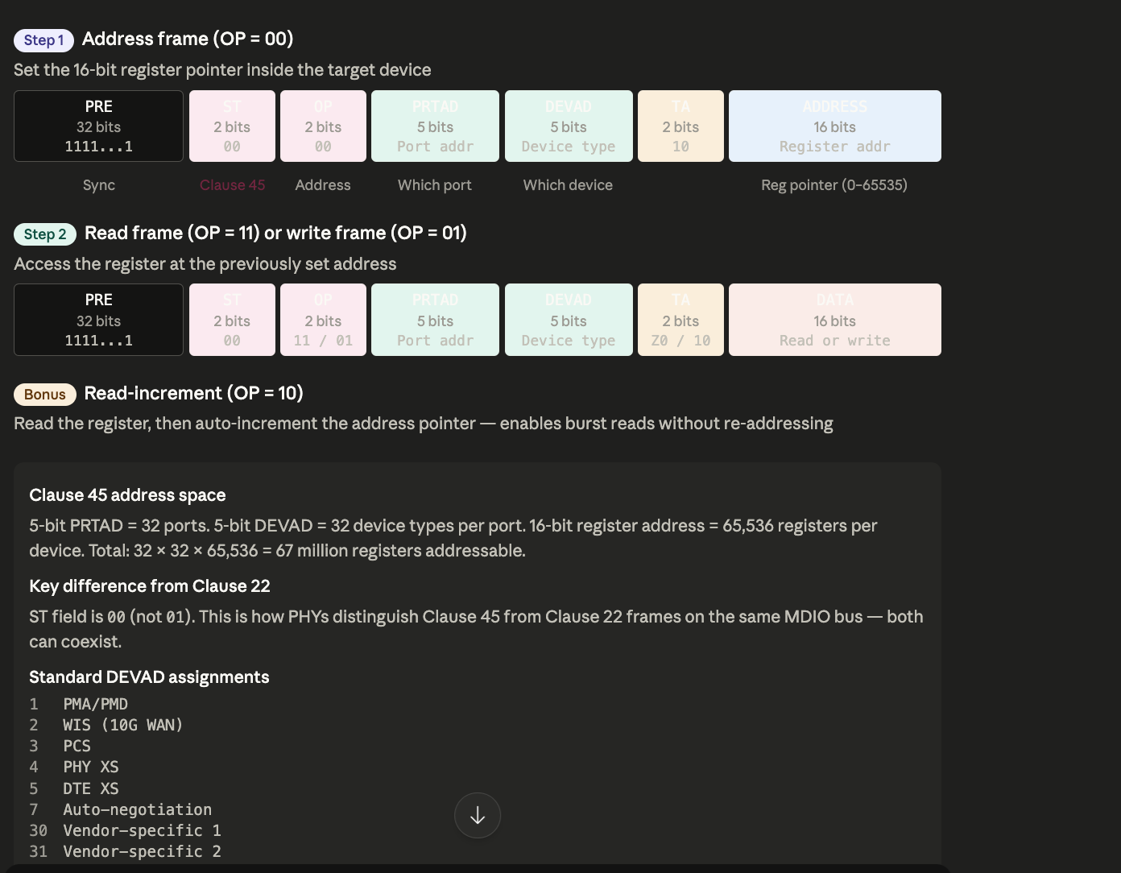

The fundamental difference is the addressing model. Let me show how the two clauses navigate their respective register spaces.

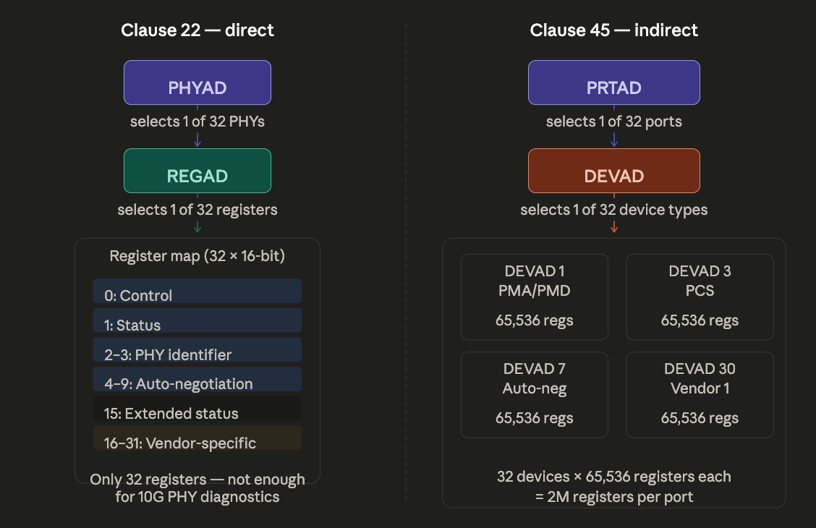
To summarise the key design decisions and practical implications:
Clause 22 uses direct addressing — the 5-bit REGAD field in the frame is the register address, and the data field in the same frame carries the value. One frame = one register access. This is fast (single transaction) but limited: 32 registers per PHY, 16 bits each. The ST (start-of-frame) field is 01.
Clause 45 uses indirect addressing — you must first send an "address" frame (OP=00) to load a 16-bit register pointer into the target device, then send a separate "read" or "write" frame to actually transfer data. Two frames minimum per access. The REGAD field of Clause 22 is repurposed as DEVAD (device address), which selects one of 32 logical sub-devices within the PHY (PMA/PMD, PCS, auto-negotiation, vendor-specific, etc.). The ST field is 00 — this is how a PHY distinguishes Clause 45 traffic from Clause 22 on the same MDIO wire. Both protocols can coexist on the same bus.
The read-increment operation (OP=10 in Clause 45) is a practical convenience: it reads the register at the current pointer and then auto-increments the pointer by 1. This allows burst-reading a block of consecutive registers — say, a 64-register diagnostic snapshot — with a single address frame followed by 64 read-increment frames, rather than 64 address + 64 read pairs. At 2.5 MHz MDC, the time savings on large register dumps is significant.
Practical context: in most embedded systems today, Clause 22 is used for simple Gigabit PHYs (the Marvell 88E1111, TI DP83867, Microchip LAN8720 and their descendants all respond on Clause 22). Clause 45 is mandatory for 10GBASE-T PHYs and is increasingly used for advanced 1G/2.5G/5G PHYs that expose link training, cable diagnostics, MACsec, and IEEE 1588 timestamping registers. Many modern PHYs support both — they respond to Clause 22 on the basic register set (0–31) and to Clause 45 for the extended feature set.

